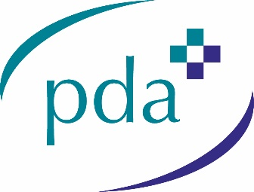
To assist our members we have recreated the text ANNEX D of the NHS Wales document to enable you to complete the form in Word.

Annex D – Locum Worker Application Form
NHS Covid-19 Bonus Payment Scheme for Primary Care
To apply for the bonus payment, you must meet the eligibility criteria in the Directions and must complete this form and submit it to the primary care provider for whom you undertook the majority of the 8 qualifying sessions during the eligible period.

The primary care provider who you wish to make an application on your behalf must receive a completed application form from you no later than 11 June 2021. The primary care provider will then add your details to their application form in order to make an application on your behalf and, if approved, receive the payment owed to you.

For approved applications, a payment of £735 will be made to the primary care provider who made the application on your behalf. The primary care provider must then make arrangements with you for the onward payment of the £735 to you, subject to any HMRC deductions.

N.B. It will be your responsibility to ensure that HMRC receives any National Insurance and/or Tax liability associated with the NHS Covid-19 bonus payment. [NEED TO CHECK LATEST IR35 RULES]

Locum workers who work in a Local Health Board-managed practice, or are directly employed through the NHS will not need to apply to a primary care provider for the NHS Covid-19 bonus payment. The bonus payment will be automatically processed via NHS payroll where the locum is eligible.

If you are unsure about your eligibility, please contact NHS Wales Shared Service Partnership - Nwssp-primarycareservices@wales.nhs.uk

Declaration
I declare to the best of my knowledge and belief that the information provided in this form is accurate and that I meet the eligibility criteria of the NHS Covid-19 Bonus Payment Scheme as an eligible locum under The Primary Care (NHS Covid-19 Bonus Payment Scheme) Directions 2021.

I confirm that I wish to make an application for the NHS Covid-19 bonus payment and that I authorise the primary care provider named below to use the information contained in this form to make such application on my behalf.

I understand and accept that if I withhold information or provide false or misleading information, action may be taken against me and I may be liable to criminal prosecution and/or civil proceedings, and I may have to repay any amount paid to me.

I consent to the disclosure of relevant information for the purpose of verification of my application in relation to the prevention and detection of fraud. An audit trail is available for inspection, either at the premises of the primary care provider making the application or on request, by a Local Health Board’s authorised officers, NHS Wales Counter Fraud Services and/or appointed auditors.

Name

Professional Registration
Number

Address

Email/Contact Number

National Insurance Number

Signature

Date

Please provide the name and address of the primary care provider to whom this Locum Worker application form is submitted and who is authorised to make an application on your behalf.

Name:-

Address:

